
3rd Grade Tribune
October 2009

September was Busy!

With the first quarter over halfway done, we are off to a great start!

I am very proud to announce Mrs. Wiechmann’s class has won the Traveling AR Trophy every week except for one! Everyone has been working and reading very hard to make this possible. Keep up the great work and of course, keep on reading!
In Math we have been busy practicing how to add, round, and subtract up to the hundreds place. We are soon moving on to number sense, the different uses of numbers, and MULTIPLICATION!!
Reading was filled with story elements, making predictions, problem & solution, steps in a process, compound words, prefixes, and parts of a book. We are moving on to cause & effect, drawing conclusions, comparing & contrasting, context clues, antonyms, and synonyms. (Phew!)
On Tuesday, October 6th we are taking a field trip to Ag Day! You’ll hear all about it in next month’s news!

Fire Safety Day

3rd graders learn all about fire safety!
On Wednesday, September 28th, firemen from Watertown Fire Rescue visited our classroom. They taught us how to safely evacuate should there be a fire. The students then got to put their new skills to the test in the Fire Safety House.
The firemen taught us to make sure smoke detectors work properly, the importance of knowing how to unlock and open bedroom windows, and that having a family meeting place are all very important. Please take time to discuss these things with your 3rd graders and families.

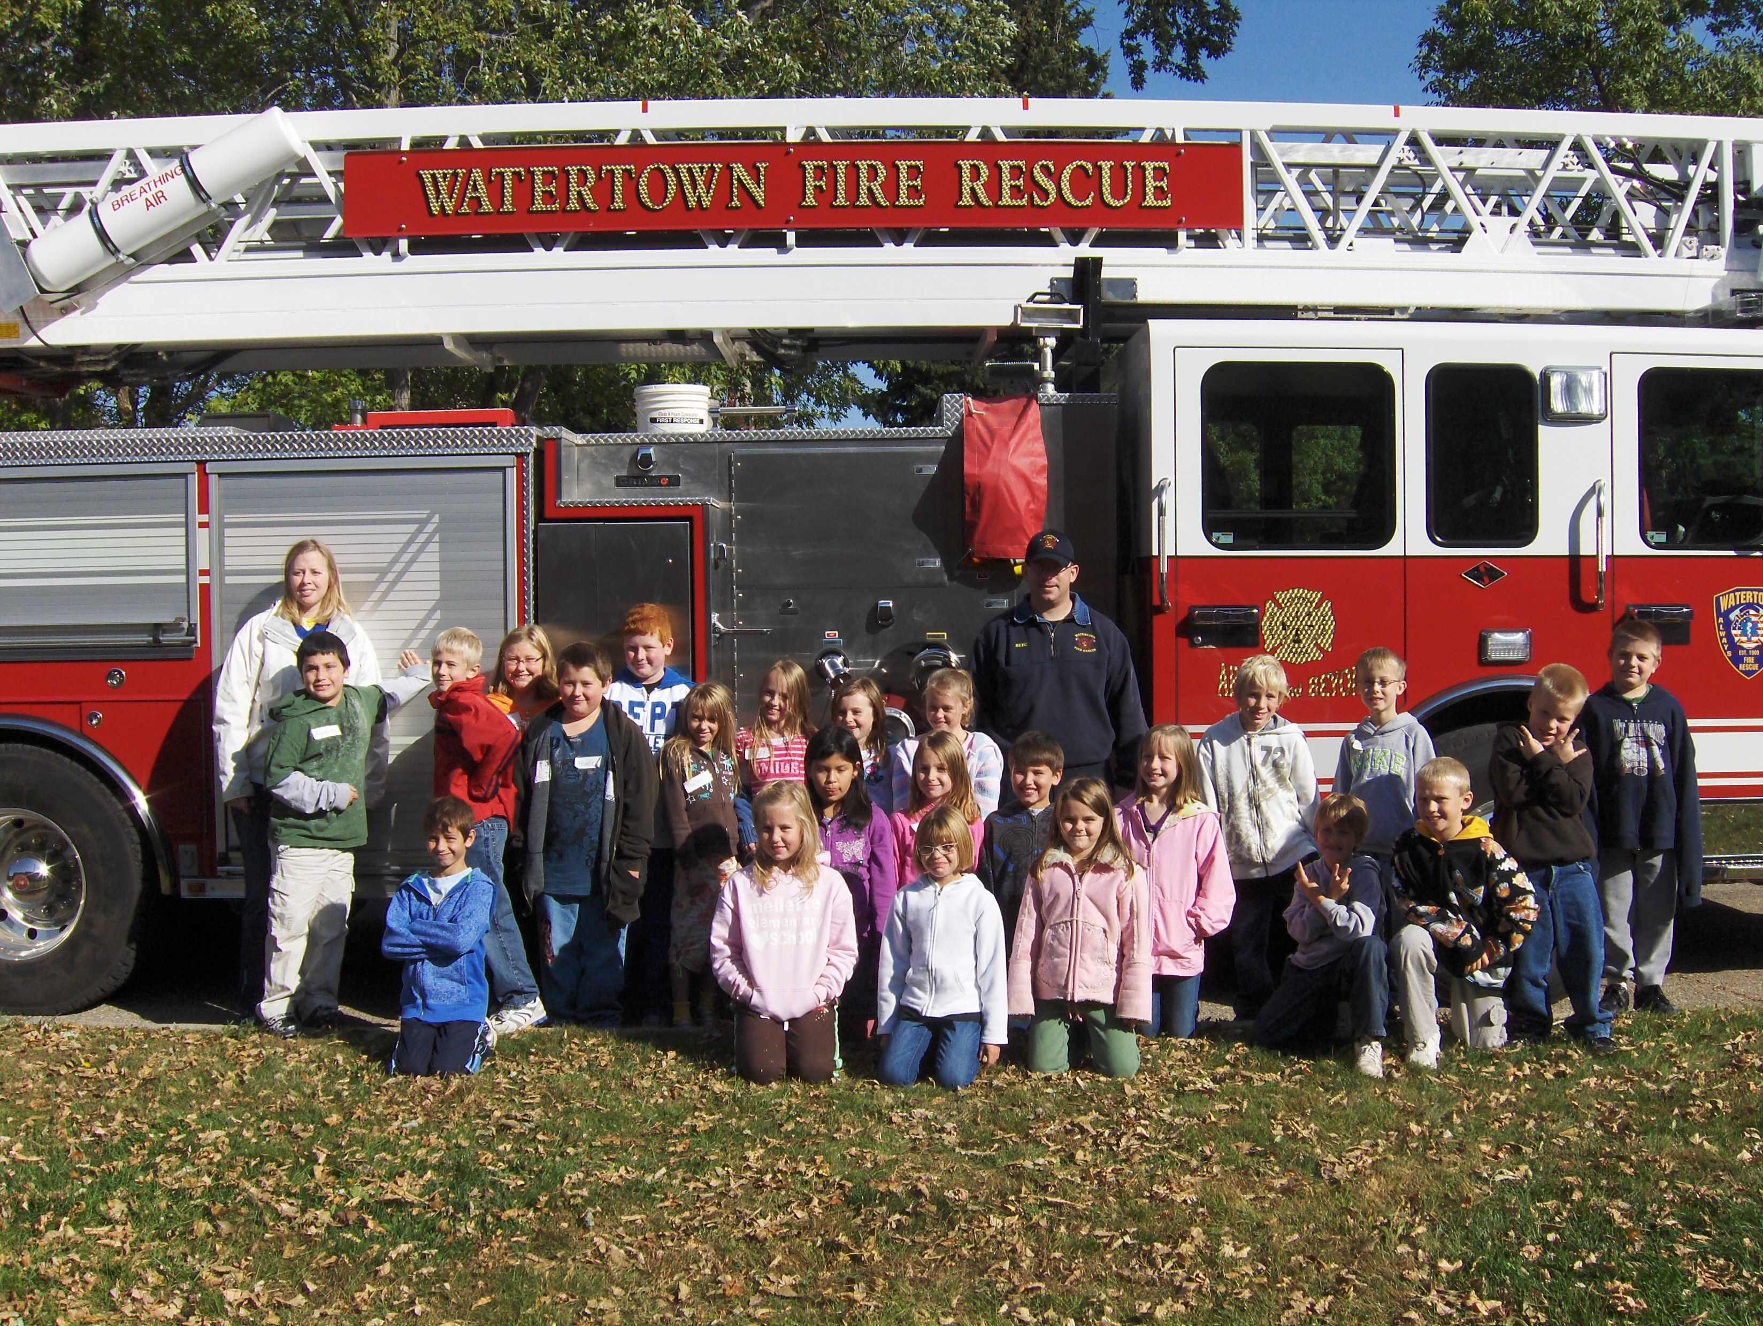

Contact Information
Email: gretchen.wiechmann@k12.sd.us
Phone: (w) 605-882-6385
(h) 605-753-0656

Website:

http://gw038.k12.sd.us/

